Lexi Cinema Visual Guide

# Getting to the cinema from Kensal Rise Overground Station

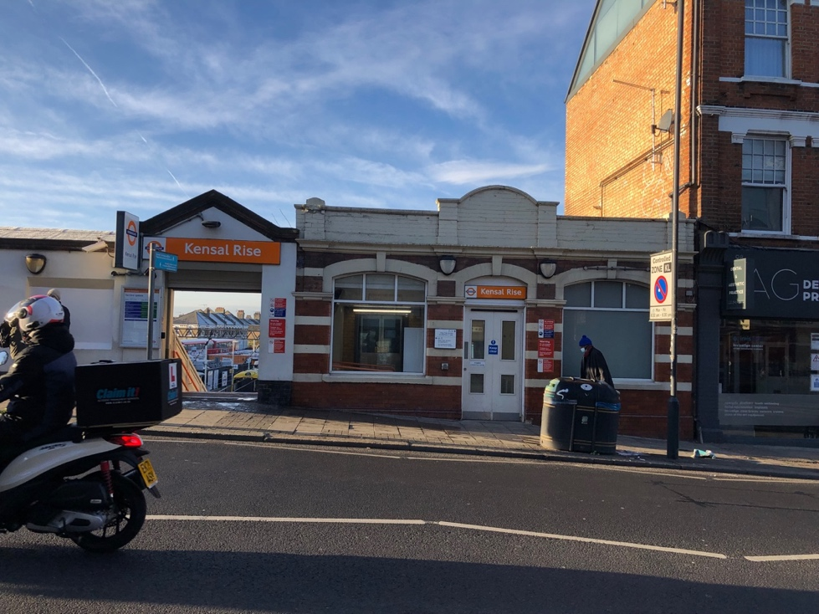

1. This is the entrance and exit to the Kensal Rise Overground station where you will

leave through when you get off the train. Platform 2 has steps free access to street

level via a lift. Turn left out of the station and continue straight along Chamberlayne road.

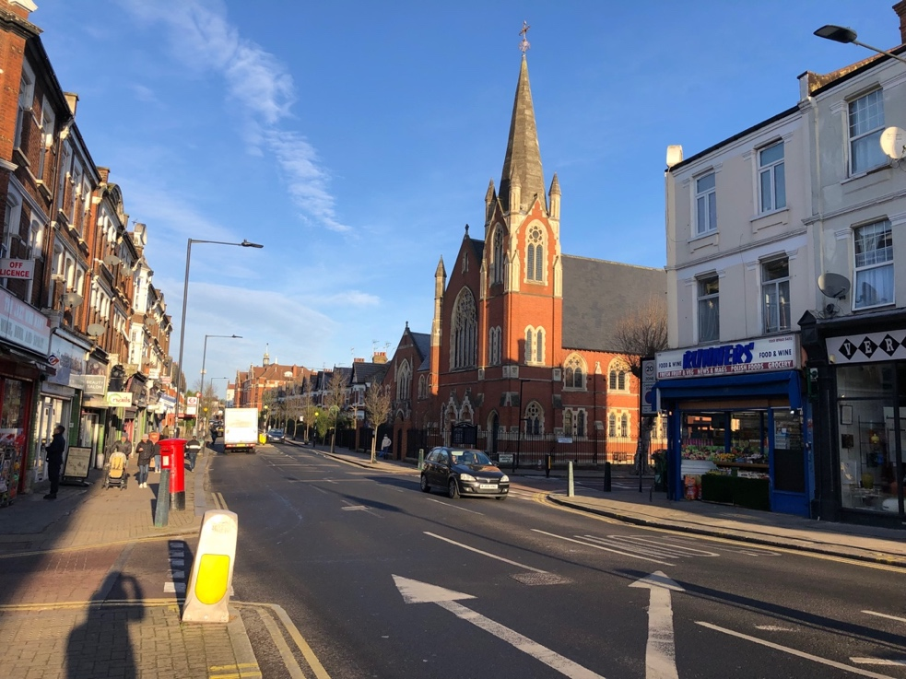

1. You will pass The Church of The Transfiguration on the right side of the road. This is a large redbrick church with a steeple. The road is quite busy with cars and may be loud. Continue up the road, past the church. You will pass lots of shops and residential homes.

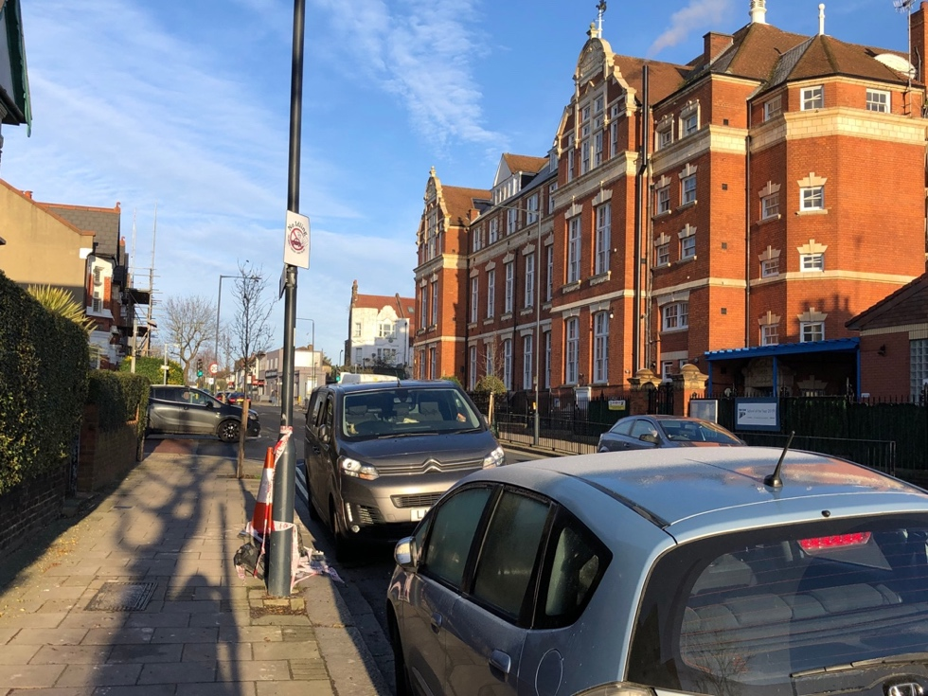

1. You will then pass the large redbrick school building on the right side of the road. Continue down this road past the school. On a weekday, there may be lots of schoolchildren entering and leaving the school, so it may be noisy.

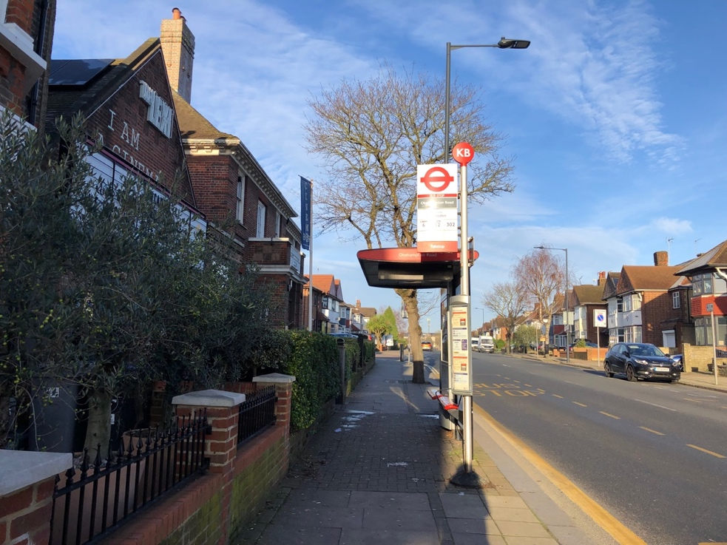

1. You will soon arrive at this bus stop, (KB), which is directly in front of the cinema. The buses that stop here are 6, 52 and 302.

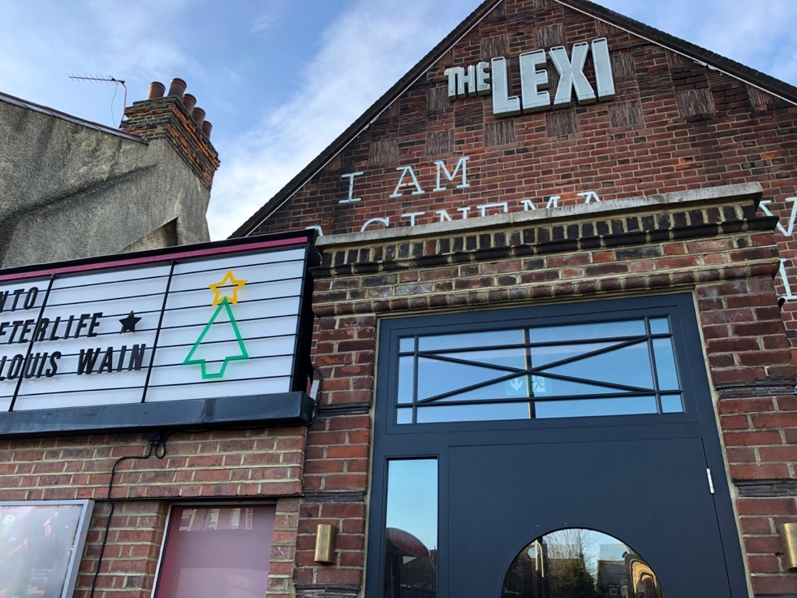

1. This is the front of the cinema. It is a redbrick one-story building. There is a large sign on the wall which says ‘THE LEXI’ and on the left, is a board that displays which films are currently showing at the cinema. This is the main entrance to the cinema.

# Access to the Box Office

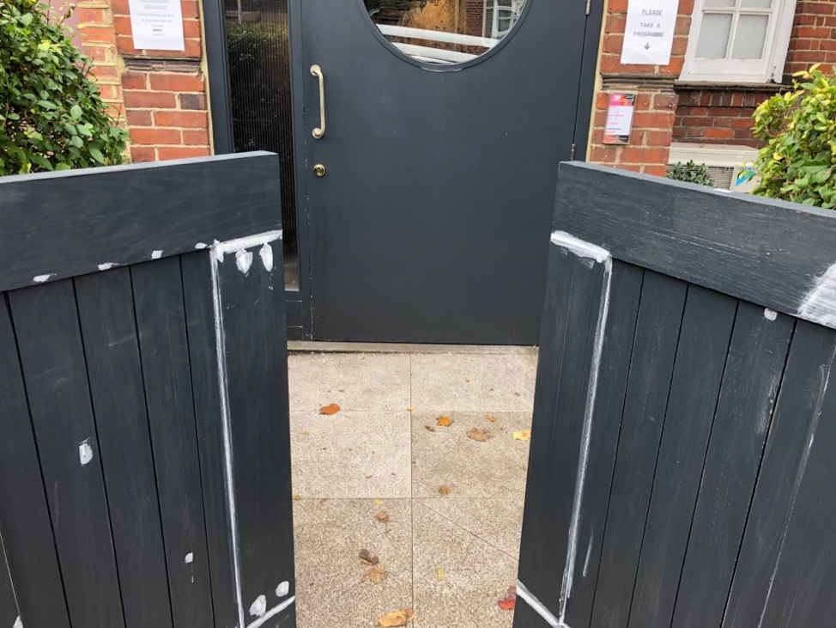

1. In front of the main door to the cinema there is a short gate that is split into two gates that open away from you.

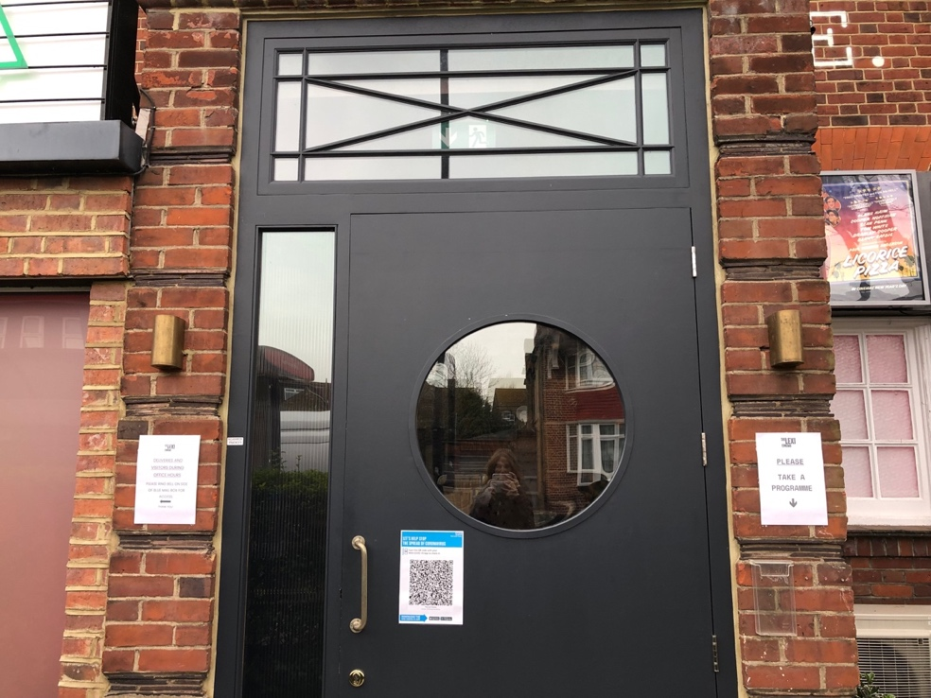

2. The large black door with a circular window is the main entrance to the Box Office and the cinema building. There is a brass handle to pull the door open, it will open towards you.

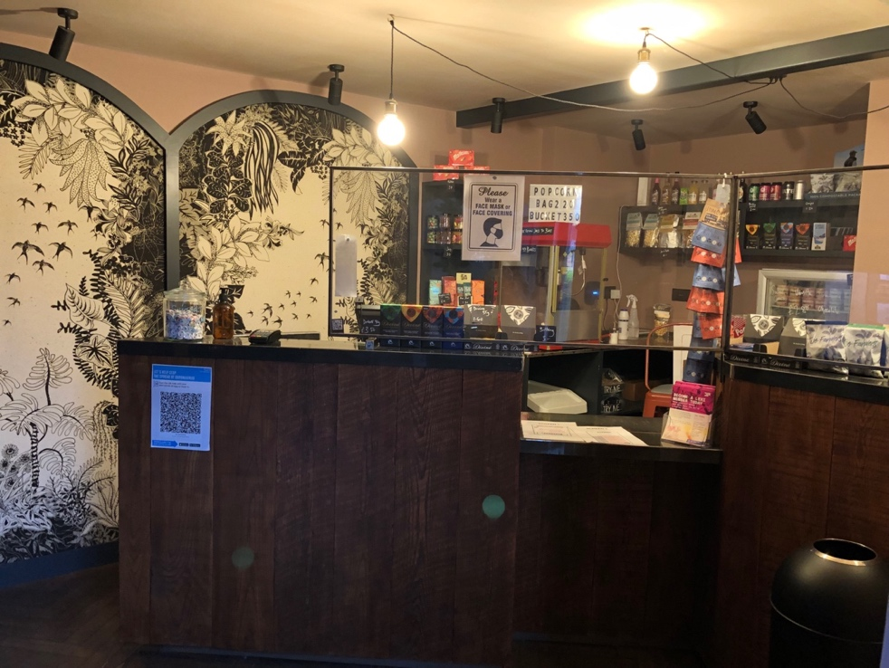

1. This is the Box Office which you will see as soon as you come through the door. There is a lowered countertop in the middle. One of the cinema’s volunteers will check your tickets and you can also buy tickets here. You can also buy popcorn, snacks, and a selection of drinks. During busy times, it can be noisy.

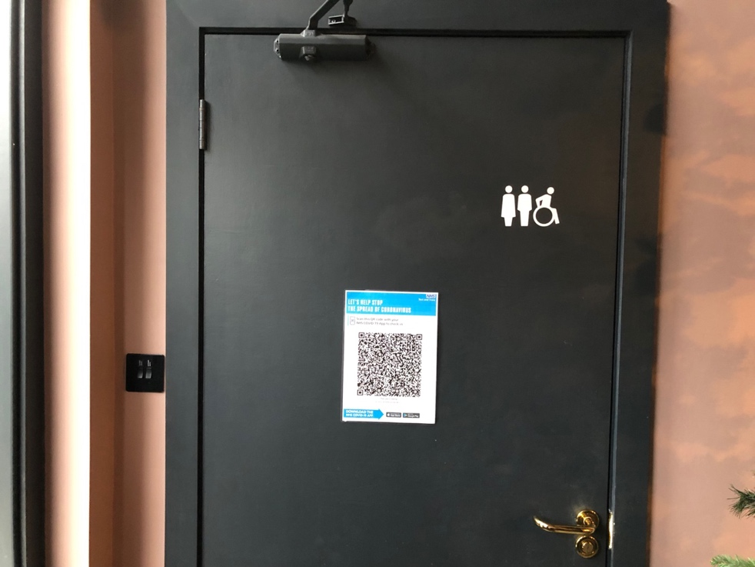

1. There is a wheelchair accessible and gender-neutral toilet on the left-hand side when you enter through the front door, the door opens towards you.

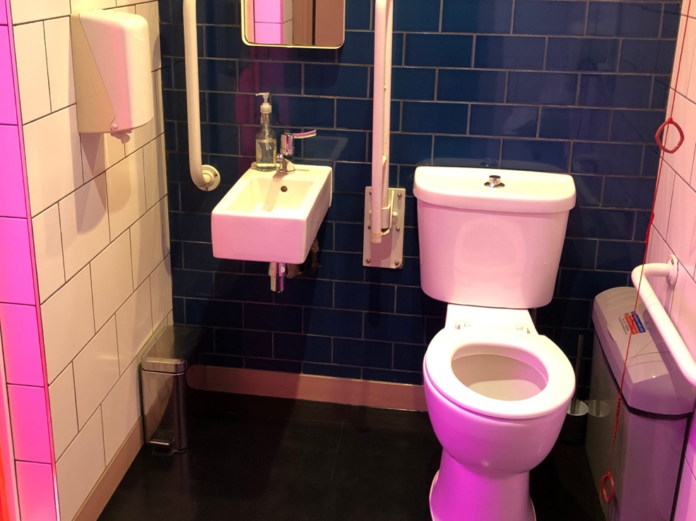

1. Inside the accessible toilet there are grab rails and a red alarm cord.

# Step Free Access to Screen 1

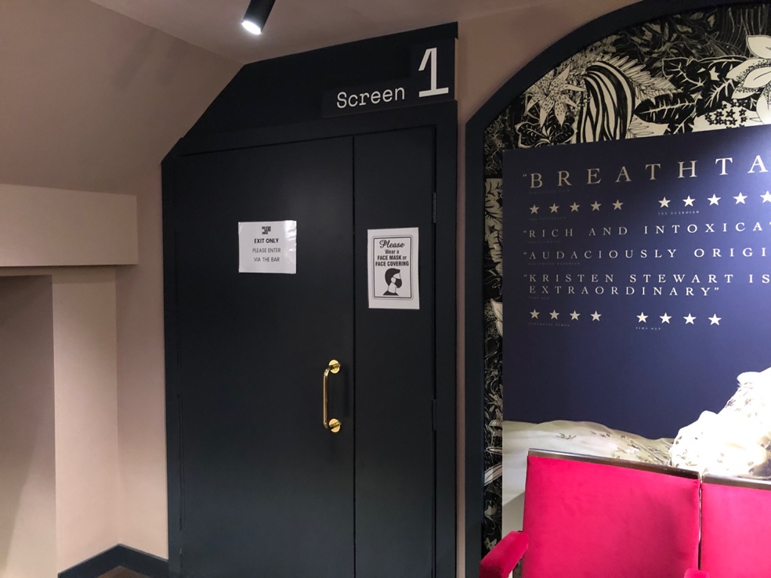

1. For step free access to Screen 1, go through this door to the left of the Box Office which will open towards you. Follow the corridor down. The seats will be on the right-hand side. Seats B1 and B2 on the front row are the designated seats for wheelchair users who wish to remain in their chairs.

# Access to Screen 1 Balcony

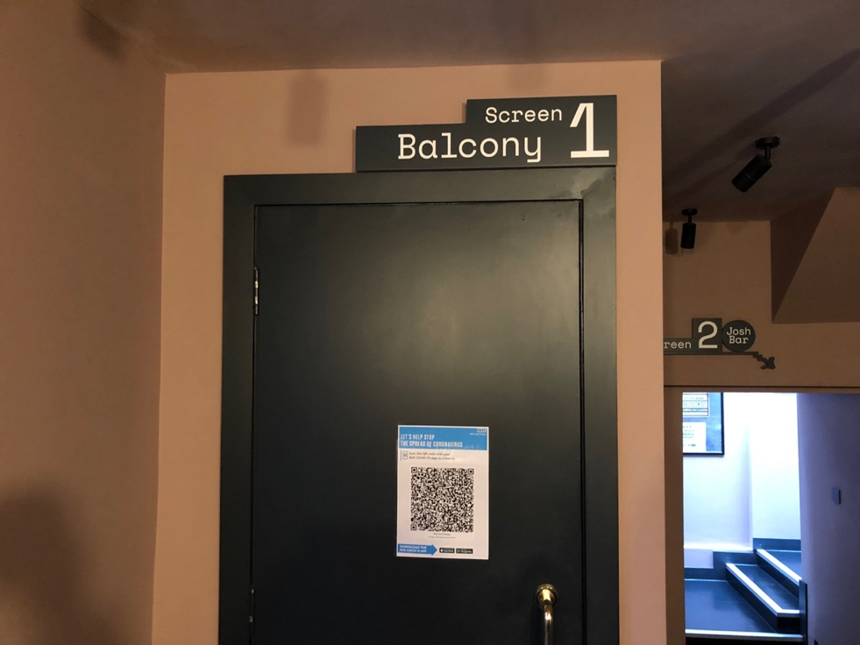

1. If your seats are in the Screen 1 balcony, you can access your seats through the door next to the accessible toilets in the Box Office. The door pulls towards you.

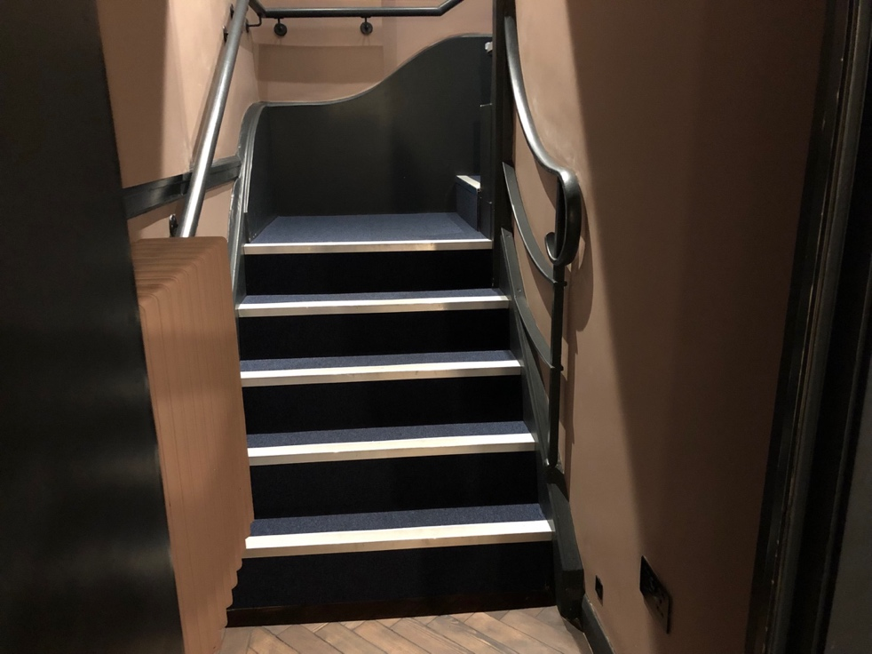

1. There are 14 steps leading up to the balcony, with a handrail on both sides. There is an additional step up to the first row of seats and another step up to the second row of seats. The steps leading up to the balcony have white contrast strips and space to rest halfway up.

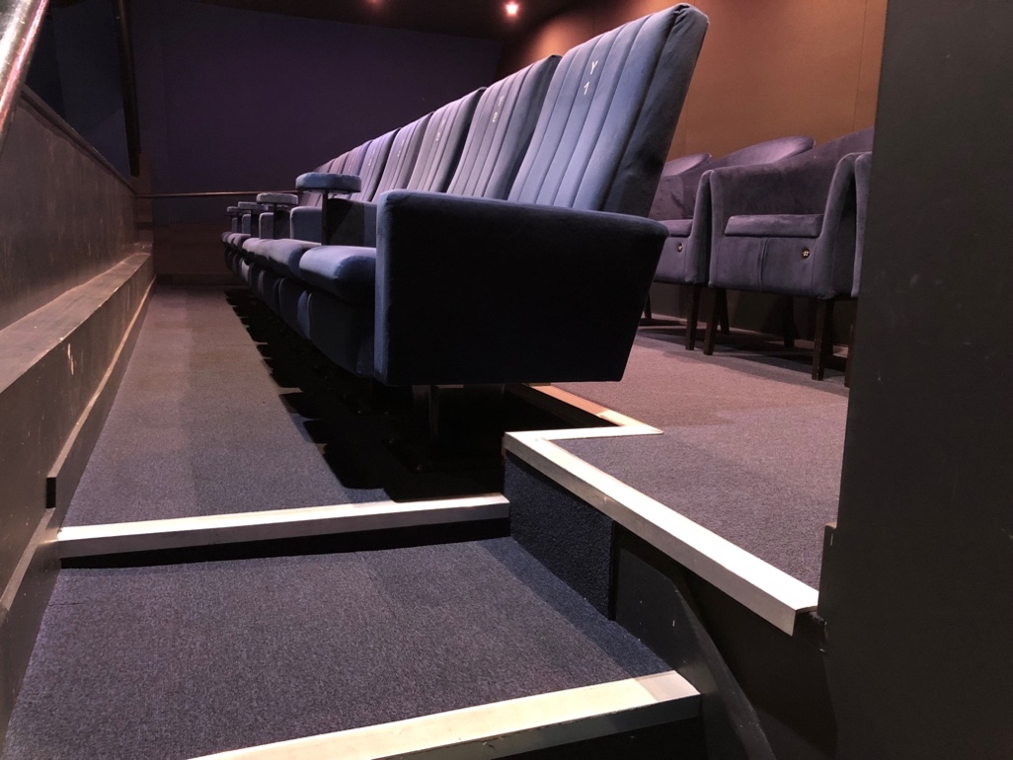

1. These are the balcony seats. The second row is not for sale so if you have balcony seats you will be in the first row.

# Accessing the main bar* and Screen 2

*Please note, there is no step-free access to the main bar. Please scroll down for step-free access to Screen 2.

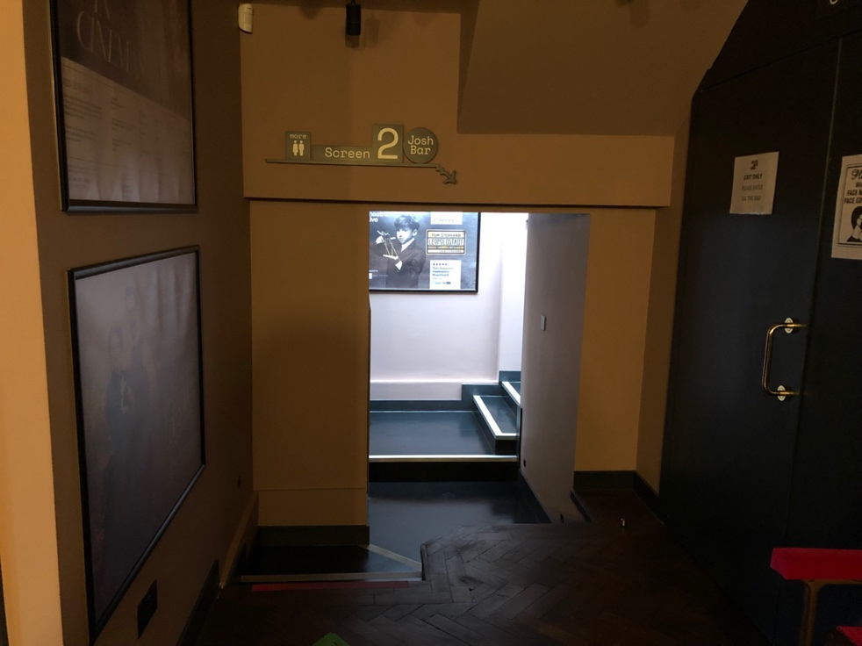

1. To access the main bar and screen 2, turn left from the box office and you will see this corridor. There are 3 steps down, followed by a step up to get to the landing of the corridor. There are 2 steps up that lead to a hallway. There are no handrails of these steps.

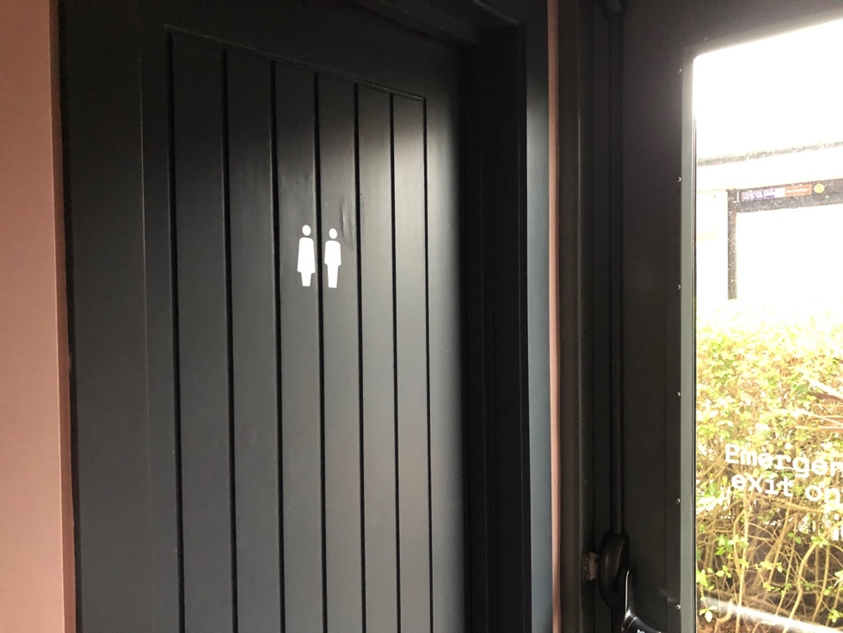

1. There is a gender-neutral toilet to the left of steps down towards the hallway, with

another two steps up. There is also an emergency exit next to the toilet which has a

handle that can be pushed to open the door.

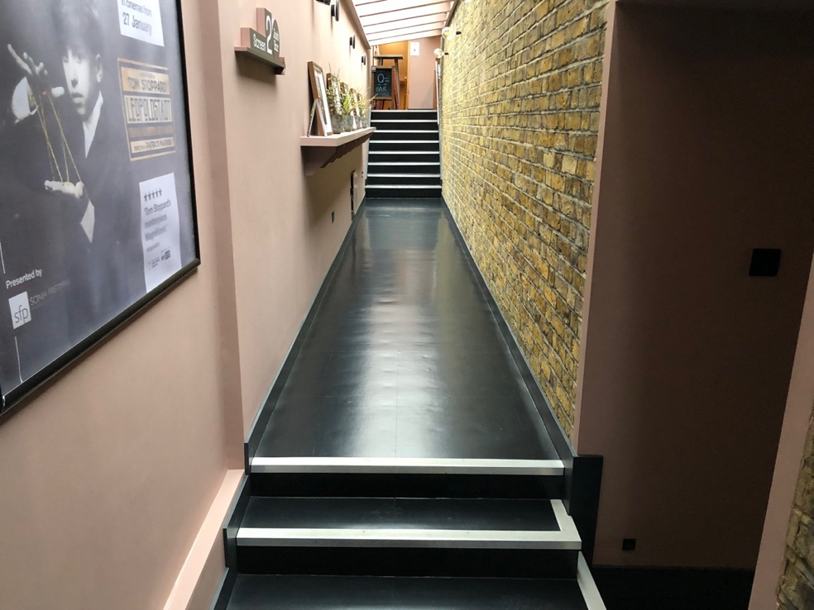

1. To get to the main bar and to access Screen 2 and an additional entrance to Screen, go up this long corridor, there are two steps up. There are another 8 steps up to the main bar with a handrail to hold. All steps have white contrast strips.

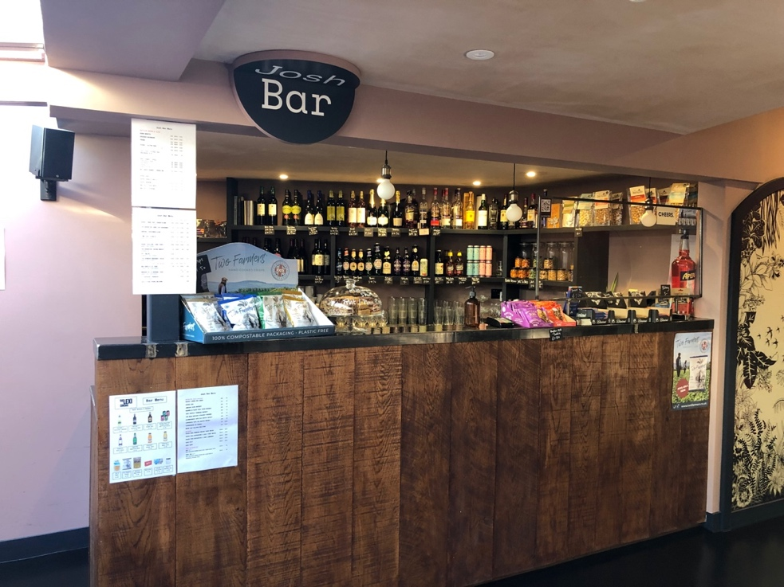

1. This is the main bar, where you can buy teas, coffees and alcoholic beverages. There will be a Duty Manager at the bar. There are some seating areas on either side with a high table, stools with backrests, and a bench with a backrest and pillows.

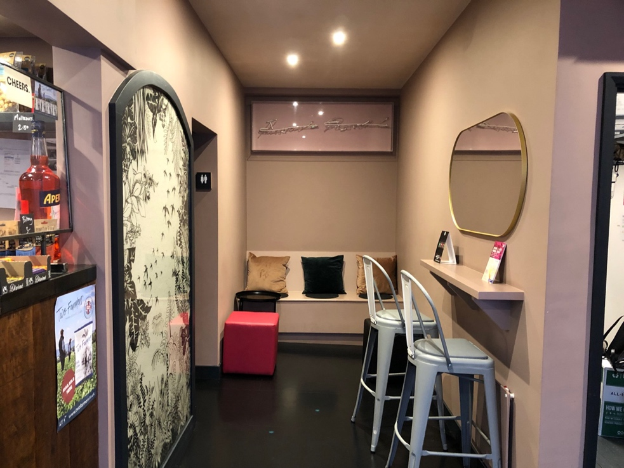

1. This is one of the seating areas to the right of the bar. On busy evenings, when the audiences are arriving for films, this area can be busy and noisy.

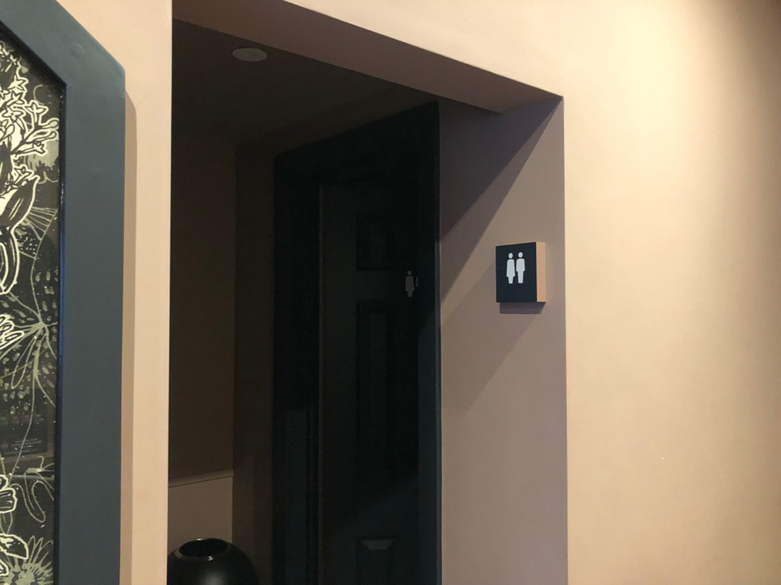

1. There are two more gender-neutral toilets to the right of the bar, they are not wheelchair accessible.

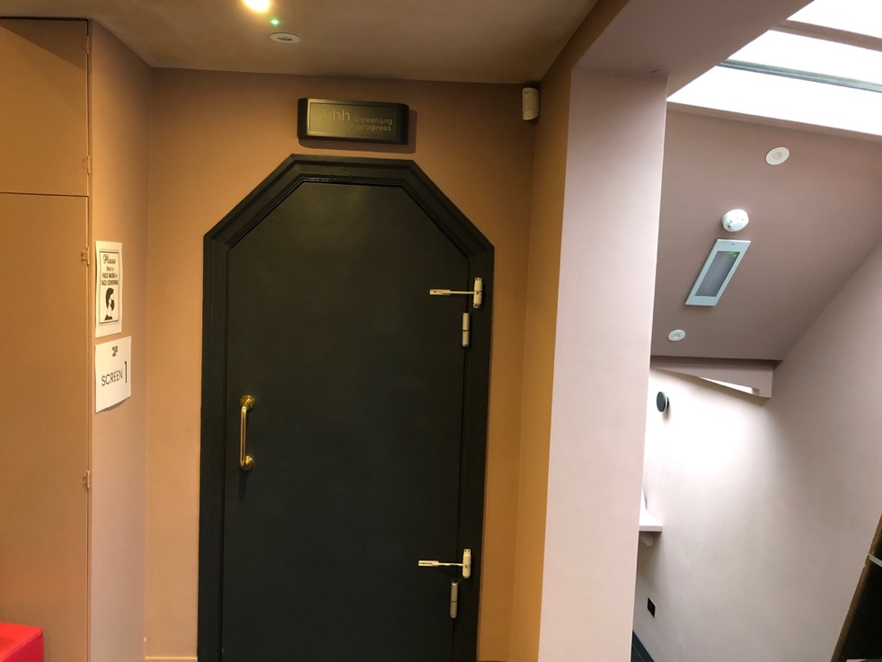

1. This is another door to Screen 1. It is directly opposite the main bar. There is one step down to the door. The first door has a handle and will open towards you. The second door needs to be pushed away from you. Before a film starts, these doors will be open. Once through the two doors, there are 6 steps down with is a handrail to the left-hand side. You will see the cinema seats in front of you to the left.

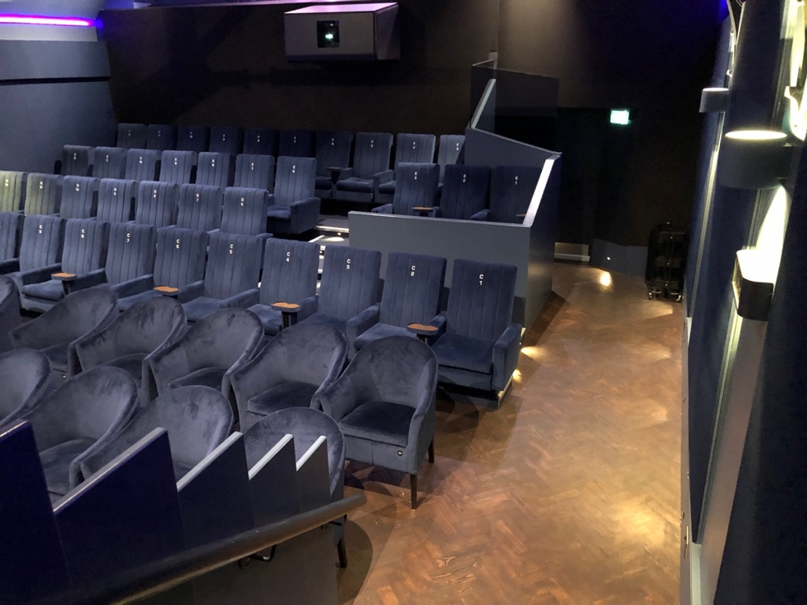

1. The cinema seats are a combination of armchairs and conventional cinema chairs. To access Row D and above, there are two steps up, and then an additional 2 steps up to Row E, and 2 additional steps up to row F.

# Access to Screen 2

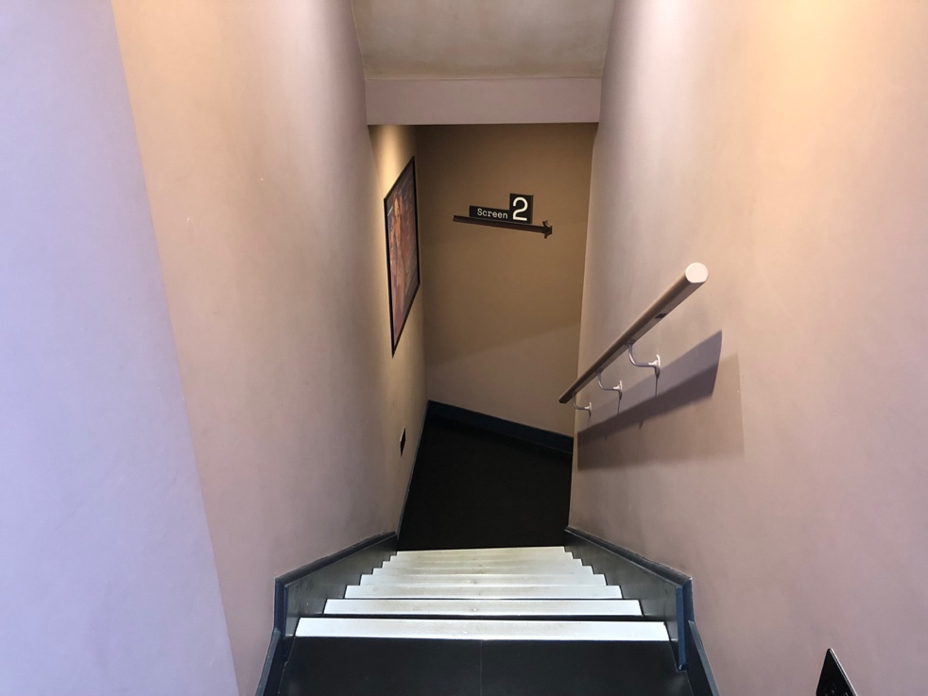

1. To get to screen 2, follow the corridor to the left of the main bar. There are 8 steep steps down, followed by another 2 steps along the corridor. You will pass the small Hub bar, which also sells snacks and a selection of drinks. Screen 2 is to the left of the Hub bar.

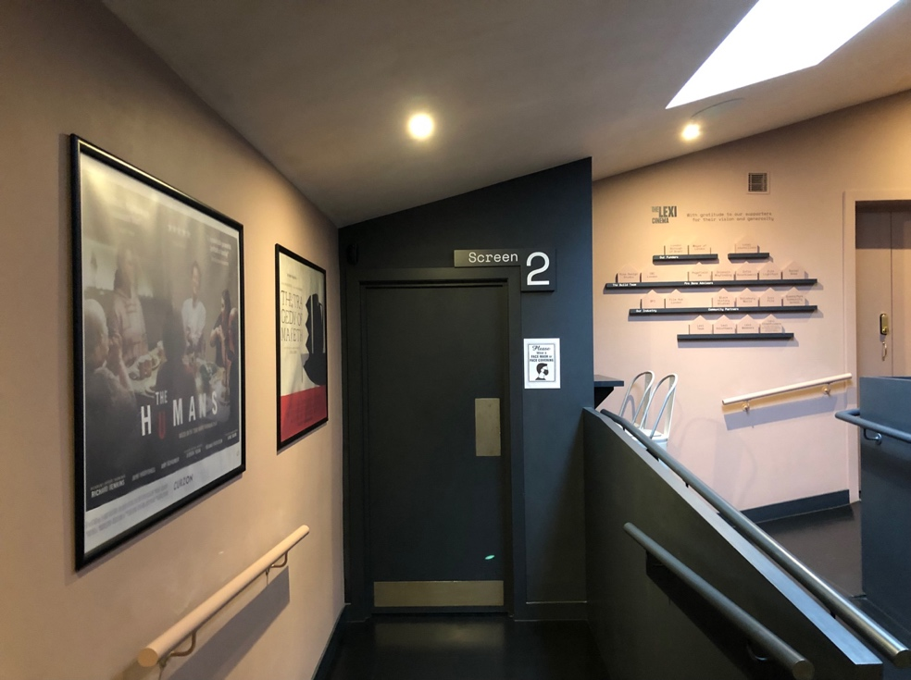

1. You will see this sign for Screen 2. The first door will open away from you. There will be a second door that also opens away from you. The doors can be quite heavy to push. On your way out there are handles on the same doors on the other side, and the doors will open towards you on the way out.

# Step Free Access to Screen 2

***\*\*\*Please note, for step free access to Screen 2, there is a gravel car park to cross, which unfortunately is not accessible to all wheelchairs. Screen 1 is wheelchair accessible.***

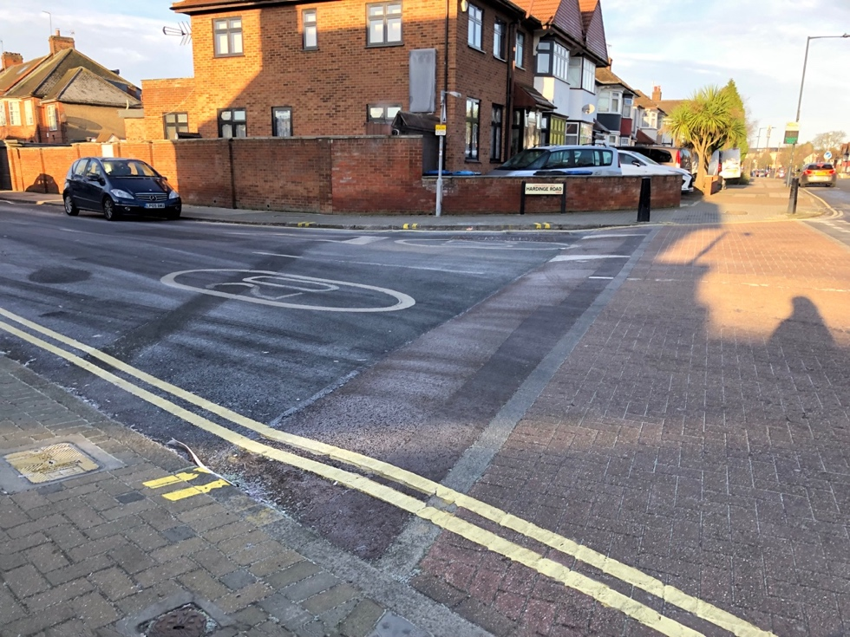

1. For step-free access to Screen 2, turn left out of the Lexi building and then turn onto Hardinge road, which is the first road on the left. You will then reach the entrance to the car park which is on the left-hand side of the pavement.

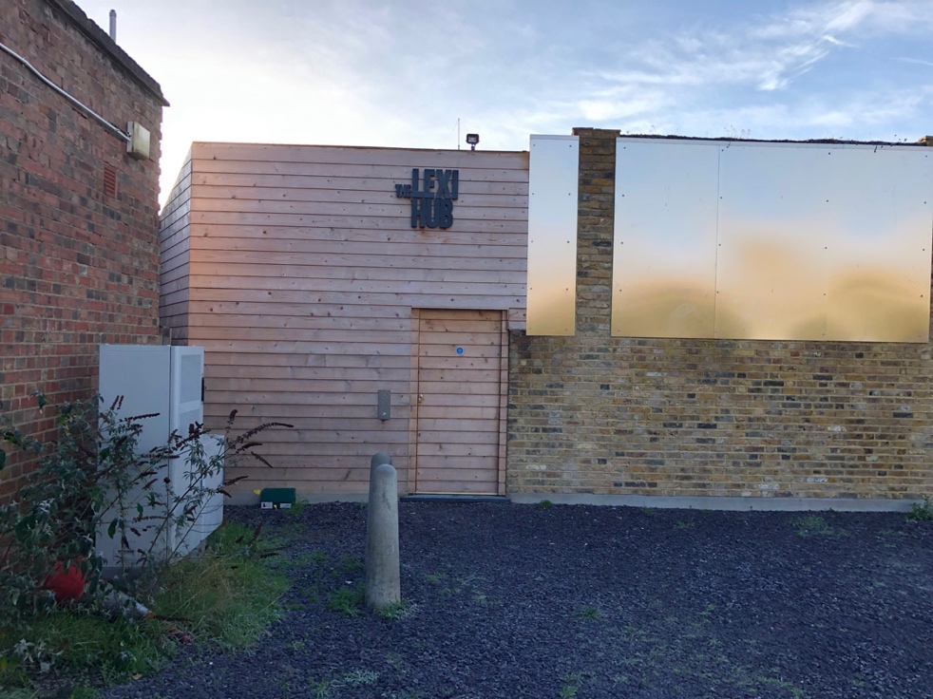

1. Cross the car park and you will see the sign for the Lexi Hub and the door to access Screen 2. There is an intercom on the left-hand side which will be answered by a Box Office volunteer who will release the door electronically so it can be opened.

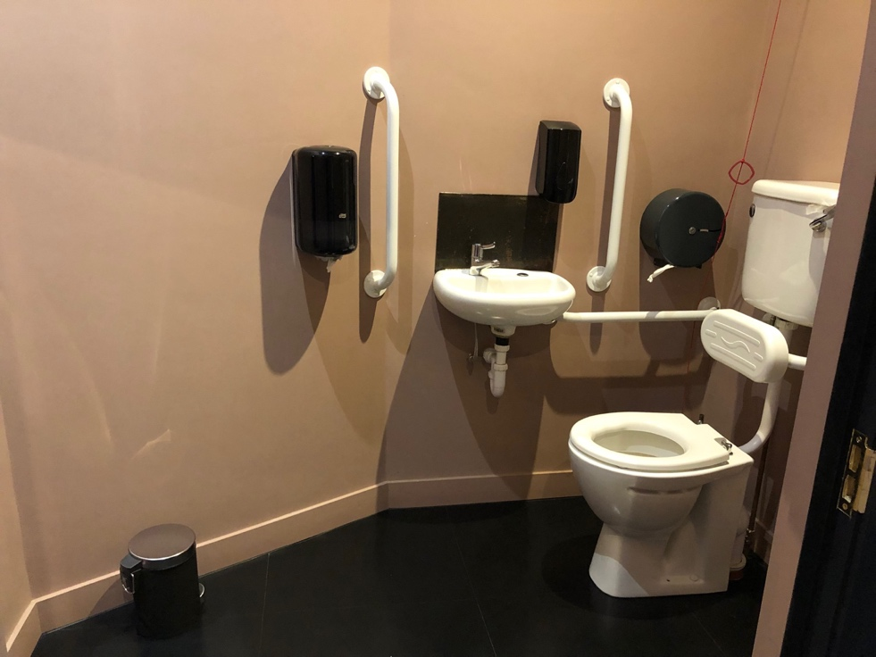

1. Once inside there is an accessible toilet on the left-hand side.

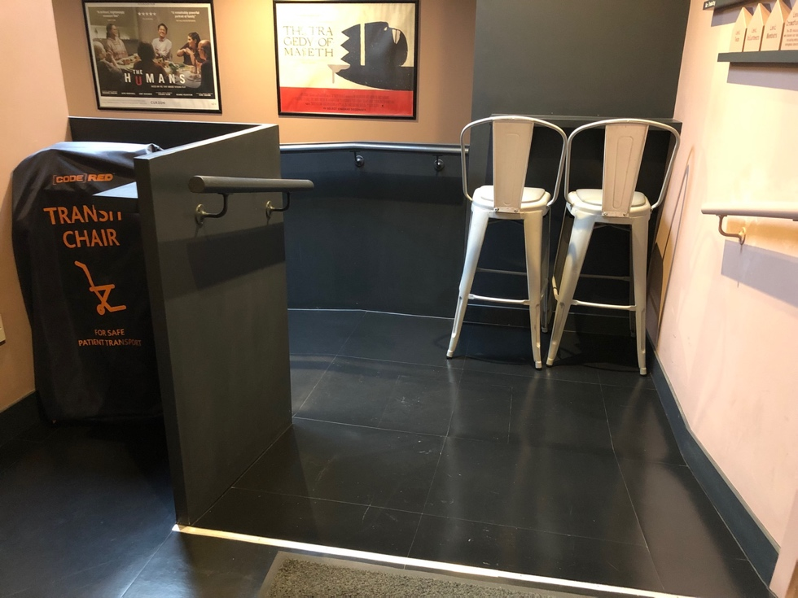

1. To get to Screen 2 there is a downward slope. Follow the ramp down past the small bar and turn right, you will see the sign for Screen 2.

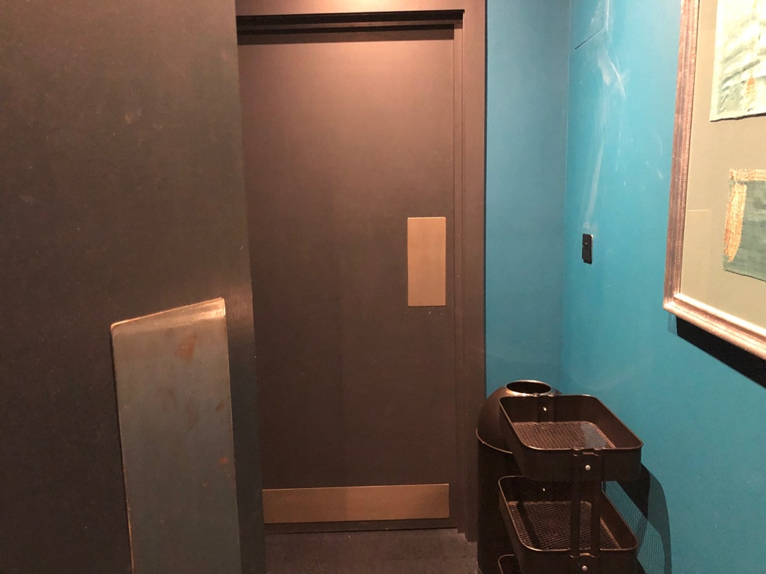

1. To enter Screen 2, push the first door which will open away from you. There will be a second door which also opens away from you. The doors can be quite heavy to push. On your way out there are handles on the same doors on the other side and the doors will open towards you on the way out.

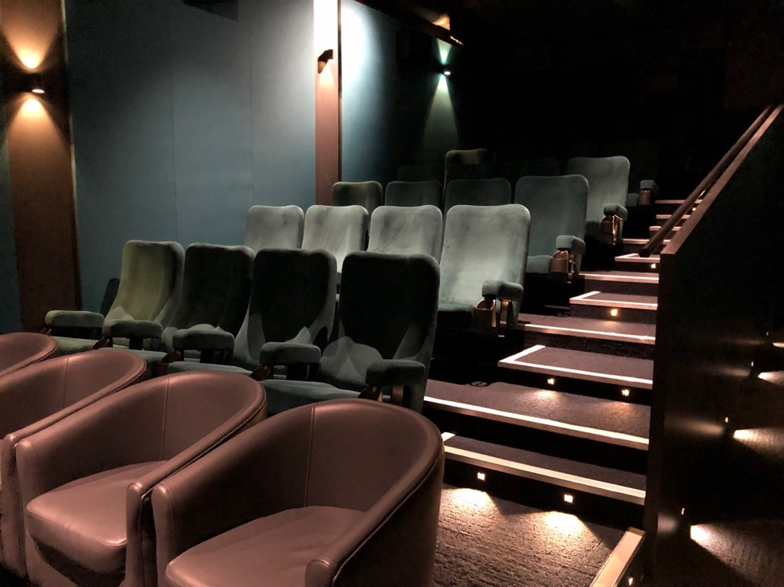

1. Once through the two doors, go down the corridor and the seats will be on the left-hand side. There is 1 step up to Row B and 11 steps up to Row G. The designated wheelchair seats for Screen 2 are A0 and A1.

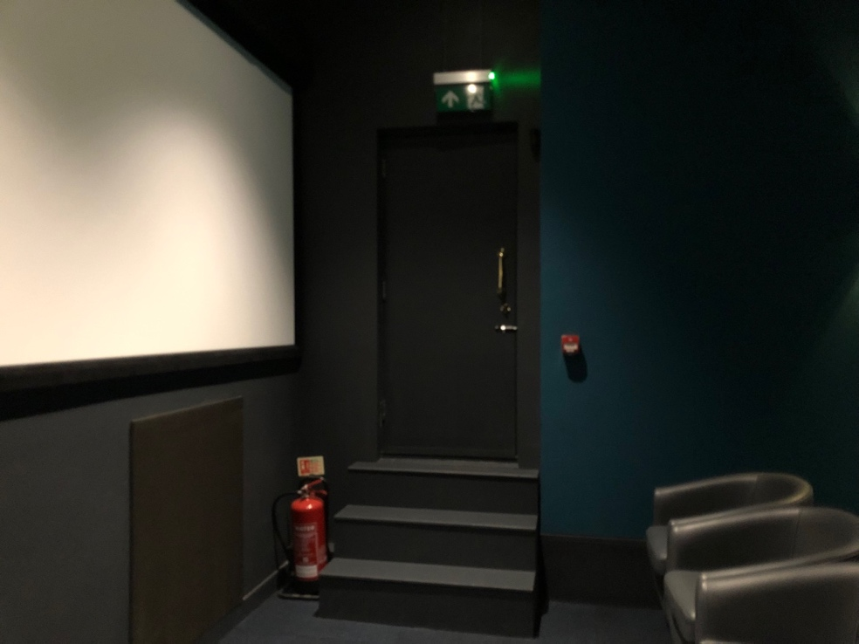

1. There is an emergency exit to the far left of the screen, with three steps up. The door opens away from you and leads you to the outdoor carpark.